Wireless Alarm Device Configuration

H411 binding with wireless alarming can be set by mobile client. This chapter will demonstrate how to configure it, by taking IOS system as example,
(1) Click Cloudsee client on the mobile, login by Cloudsee ID. Add H411 first and then open “setting” interface, click “alarming device” button.
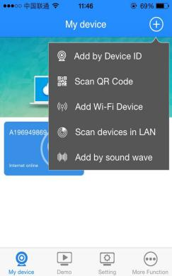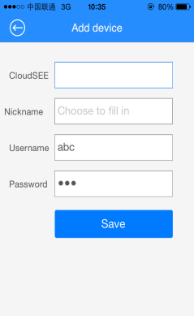
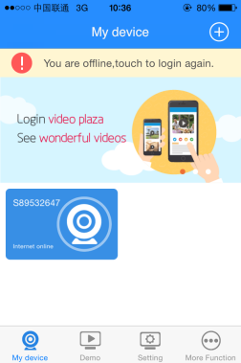
(2) Click “add-device” button to add wireless alarming device required.

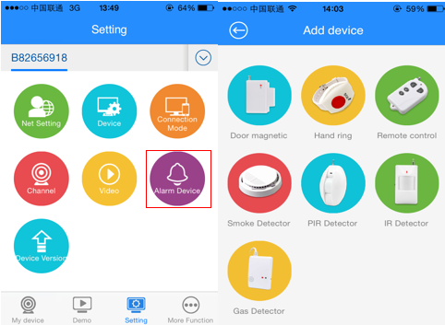
(3) Follow the system prompt to enable device, which will automatically match with H411, then fill in the following dialogue box by nickname-modify.
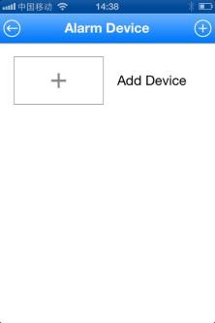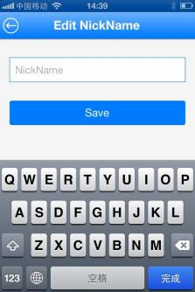
Wireless device is matching with H411………

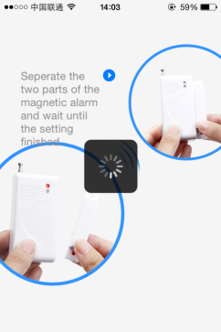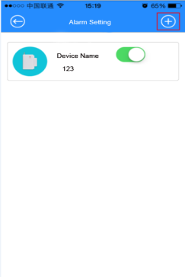
(4) After successful binding, only after you enable “Safeguard” function, can your mobile receive the alarming info. (Method to enable “safeguard” function: Device setAlarming setenable “Safeguard”).
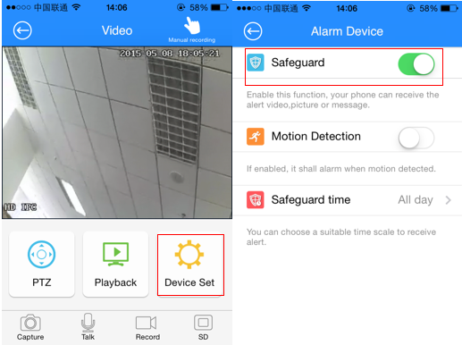
(5) After you enable “safeguard”, if wireless device detect alarming info, information will be forwarded to your cellphone and mobile will pop-up message forward box. You can check alarming messages by click it.
